﻿﻿﻿﻿﻿﻿W﻿﻿﻿﻿﻿﻿﻿﻿﻿﻿﻿﻿ithout Prejudice
Date: 08/01/2026

Ref: LRN/${sno} /01-26
To,
${name}
${address}
${pincode}
Subject: Loan Recall Notice for Loan Account No. ${lan}
Dear Mr./Ms ${name},
We wish to inform you that you had availed a loan facility of ₹ ${loan_amt} ( ${loan_amt_InWord} ) from us under Loan Agreement No. ${lan} dated ${agreement_date} . You were required to repay the said loan along with applicable interest and charges through equated monthly instalments (EMIs) as per the agreed repayment schedule.
Despite repeated reminders, we note that several EMIs remain unpaid and multiple payment instructions (cheques/NACH) have been dishonoured. Consequently, your loan account has been classified as Non-Performing Asset (NPA).
Due to your continued default and failure to regularise the account, your loan has now been formally recalled. Total Outstanding amount payable by you ₹ ${disputed_amount} (${disputed_amount_InWord}), inclusive of interest and other applicable charges.
You are hereby called upon to make full payment of the aforesaid outstanding amount within 7 (seven) days of receipt of this notice. Failure to do so shall compel us to initiate appropriate legal action, including but not limited to:
1. Proceedings under Section 138 of the Negotiable Instruments Act and Section 25 of the Payment and Settlement Systems Act for dishonoured cheques/ECS mandates.
2. Arbitration or Civil recovery proceedings for recovery of dues and attachment of assets.
3. Reporting of your default to credit bureaus (such as CIBIL), which may adversely affect your credit score and eligibility for future loans.
4. For eligible cases, proceedings under the Insolvency and Bankruptcy Code, 2016 before the National Company Law Tribunal (NCLT).
Please note that interest and other applicable charges shall continue to accrue till the date of full and final payment.
In case you have already cleared the dues, please disregard this notice. Otherwise, we urge you to contact our Area Collection Manager, Mr./Ms. ${acm_name} at ${acm_contact_number} immediately to discuss repayment and avoid further action. This notice is issued without prejudice to our rights and remedies available under the law.
Kindly ignore this communication in case you have already settled the above amount due on your Account.
Yours sincerely,
Signature 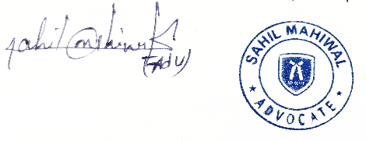

﻿﻿﻿﻿﻿﻿
Advocate Sahil Mahiwal

